HACKS DISSAPPER DONT BECOME INVIS

Click 12 buttons

<div class="arts__modal___VpEAD-camelCase"><div class="styles__container___19be4-camelCase"><div class="styles__overlay___I1jh5-camelCase"></div><div class="styles__header___3estK-camelCase">HACKED: b (-45)</div><div class="styles__desc___1Mg77-camelCase">Click 3 Buttons</div><div class="styles__buttonContainer___3XYeN-camelCase"><div class="styles__button___C94Th-camelCase" role="button" tabindex="0" style="opacity: 1;"><div class="styles__buttonInside___3If0V-camelCase">×</div></div><div class="styles__button___C94Th-camelCase" role="button" tabindex="0" style="opacity: 1;"><div class="styles__buttonInside___3If0V-camelCase">×</div></div><div class="styles__button___C94Th-camelCase" role="button" tabindex="0" style="opacity: 1;"><div class="styles__buttonInside___3If0V-camelCase">×</div></div><div class="styles__button___C94Th-camelCase" role="button" tabindex="0" style="opacity: 1;"><div class="styles__buttonInside___3If0V-camelCase">×</div></div><div class="styles__button___C94Th-camelCase" role="button" tabindex="0" style="opacity: 1;"><div class="styles__buttonInside___3If0V-camelCase">×</div></div><div class="styles__button___C94Th-camelCase" role="button" tabindex="0" style="opacity: 1;"><div class="styles__buttonInside___3If0V-camelCase">×</div></div><div class="styles__button___C94Th-camelCase" role="button" tabindex="0" style="opacity: 1;"><div class="styles__buttonInside___3If0V-camelCase">×</div></div><div class="styles__button___C94Th-camelCase" role="button" tabindex="0" style="opacity: 1;"><div class="styles__buttonInside___3If0V-camelCase">×</div></div><div class="styles__button___C94Th-camelCase" role="button" tabindex="0" style="opacity: 1;"><div class="styles__buttonInside___3If0V-camelCase">×</div></div><div class="styles__button___C94Th-camelCase" role="button" tabindex="0" style="opacity: 1;"><div class="styles__buttonInside___3If0V-camelCase">×</div></div></div></div></div>

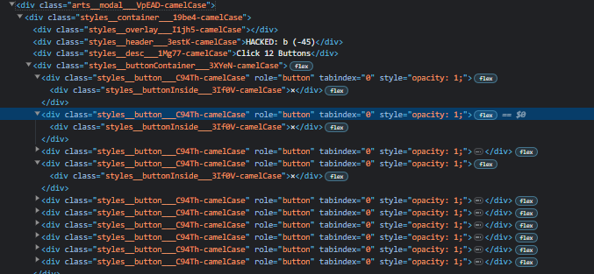

Unclickable buttons:  
<div class="styles__button___C94Th-camelCase styles__noClick___39ylx-camelCase" role="button" tabindex="0" style="opacity: 0;"><div class="styles__buttonInside___3If0V-camelCase">×</div></div>

Text turns to click 0 buttons before ending

Hack window deletes itself doesnt disappear

Repeat the pattern  
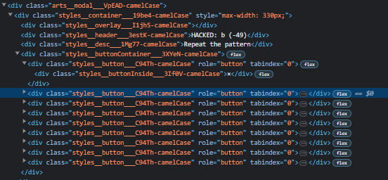

<div class="arts__modal___VpEAD-camelCase"><div class="styles__container___19be4-camelCase" style="max-width: 330px;"><div class="styles__overlay___I1jh5-camelCase"></div><div class="styles__header___3estK-camelCase">HACKED: b (-49)</div><div class="styles__desc___1Mg77-camelCase">Repeat the pattern</div><div class="styles__buttonContainer___3XYeN-camelCase"><div class="styles__button___C94Th-camelCase" role="button" tabindex="0"><div class="styles__buttonInside___3If0V-camelCase">×</div></div><div class="styles__button___C94Th-camelCase" role="button" tabindex="0"><div class="styles__buttonInside___3If0V-camelCase">×</div></div><div class="styles__button___C94Th-camelCase" role="button" tabindex="0"><div class="styles__buttonInside___3If0V-camelCase">×</div></div><div class="styles__button___C94Th-camelCase" role="button" tabindex="0"><div class="styles__buttonInside___3If0V-camelCase">×</div></div><div class="styles__button___C94Th-camelCase" role="button" tabindex="0"><div class="styles__buttonInside___3If0V-camelCase">×</div></div><div class="styles__button___C94Th-camelCase" role="button" tabindex="0"><div class="styles__buttonInside___3If0V-camelCase">×</div></div><div class="styles__button___C94Th-camelCase" role="button" tabindex="0"><div class="styles__buttonInside___3If0V-camelCase">×</div></div><div class="styles__button___C94Th-camelCase" role="button" tabindex="0"><div class="styles__buttonInside___3If0V-camelCase">×</div></div><div class="styles__button___C94Th-camelCase" role="button" tabindex="0"><div class="styles__buttonInside___3If0V-camelCase">×</div></div></div></div></div>

After clicking: <div class="styles__button___C94Th-camelCase styles__chosen___3pT3X-camelCase" role="button" tabindex="0"><div class="styles__buttonInside___3If0V-camelCase">×</div></div>

Make all buttons the same color

Order: star, circle, heart, square, star

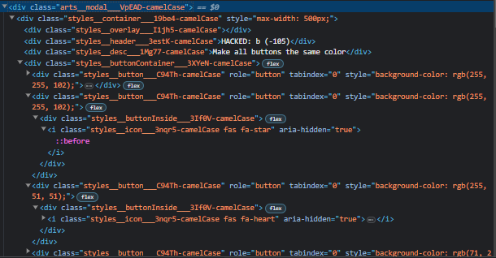

<div class="arts__modal___VpEAD-camelCase"><div class="styles__container___19be4-camelCase" style="max-width: 500px;"><div class="styles__overlay___I1jh5-camelCase"></div><div class="styles__header___3estK-camelCase">HACKED: b (-105)</div><div class="styles__desc___1Mg77-camelCase">Make all buttons the same color</div><div class="styles__buttonContainer___3XYeN-camelCase"><div class="styles__button___C94Th-camelCase" role="button" tabindex="0" style="background-color: rgb(255, 255, 102);"><div class="styles__buttonInside___3If0V-camelCase"><i class="styles__icon___3nqr5-camelCase fas fa-star" aria-hidden="true"></i></div></div><div class="styles__button___C94Th-camelCase" role="button" tabindex="0" style="background-color: rgb(255, 255, 102);"><div class="styles__buttonInside___3If0V-camelCase"><i class="styles__icon___3nqr5-camelCase fas fa-star" aria-hidden="true"></i></div></div><div class="styles__button___C94Th-camelCase" role="button" tabindex="0" style="background-color: rgb(255, 51, 51);"><div class="styles__buttonInside___3If0V-camelCase"><i class="styles__icon___3nqr5-camelCase fas fa-heart" aria-hidden="true"></i></div></div><div class="styles__button___C94Th-camelCase" role="button" tabindex="0" style="background-color: rgb(71, 209, 71);"><div class="styles__buttonInside___3If0V-camelCase"><i class="styles__icon___3nqr5-camelCase fas fa-square" aria-hidden="true"></i></div></div><div class="styles__button___C94Th-camelCase" role="button" tabindex="0" style="background-color: rgb(51, 133, 255);"><div class="styles__buttonInside___3If0V-camelCase"><i class="styles__icon___3nqr5-camelCase fas fa-circle" aria-hidden="true"></i></div></div><div class="styles__button___C94Th-camelCase" role="button" tabindex="0" style="background-color: rgb(255, 51, 51);"><div class="styles__buttonInside___3If0V-camelCase"><i class="styles__icon___3nqr5-camelCase fas fa-heart" aria-hidden="true"></i></div></div><div class="styles__button___C94Th-camelCase" role="button" tabindex="0" style="background-color: rgb(255, 51, 51);"><div class="styles__buttonInside___3If0V-camelCase"><i class="styles__icon___3nqr5-camelCase fas fa-heart" aria-hidden="true"></i></div></div><div class="styles__button___C94Th-camelCase" role="button" tabindex="0" style="background-color: rgb(255, 51, 51);"><div class="styles__buttonInside___3If0V-camelCase"><i class="styles__icon___3nqr5-camelCase fas fa-heart" aria-hidden="true"></i></div></div></div></div></div>

Find the matching cards:

<div class="arts__modal___VpEAD-camelCase"><div class="styles__container___19be4-camelCase" style="max-width: 500px;"><div class="styles__overlay___I1jh5-camelCase"></div><div class="styles__header___3estK-camelCase">HACKED: b (-113)</div><div class="styles__desc___1Mg77-camelCase">Find the matching cards</div><div class="styles__buttonContainer___3XYeN-camelCase"><div class="styles__button___C94Th-camelCase" role="button" tabindex="0"><div class="styles__buttonInside___3If0V-camelCase"><div class="styles__blookContainer___36LK2-camelCase styles__cardBlook___BpxvN-camelCase"><img src="https://blooket.s3.us-east-2.amazonaws.com/blooks/bots/brainyBot.svg" alt="Brainy Bot Blook" draggable="false" class="styles__blook___1R6So-camelCase"></div></div></div><div class="styles__button___C94Th-camelCase" role="button" tabindex="0"><div class="styles__buttonInside___3If0V-camelCase"><div class="styles__blookContainer___36LK2-camelCase styles__cardBlook___BpxvN-camelCase"><img src="https://blooket.s3.us-east-2.amazonaws.com/blooks/bots/lovelyBot.svg" alt="Lovely Bot Blook" draggable="false" class="styles__blook___1R6So-camelCase"></div></div></div><div class="styles__button___C94Th-camelCase" role="button" tabindex="0"><div class="styles__buttonInside___3If0V-camelCase"><div class="styles__blookContainer___36LK2-camelCase styles__cardBlook___BpxvN-camelCase"><img src="https://blooket.s3.us-east-2.amazonaws.com/blooks/bots/lovelyBot.svg" alt="Lovely Bot Blook" draggable="false" class="styles__blook___1R6So-camelCase"></div></div></div><div class="styles__button___C94Th-camelCase" role="button" tabindex="0"><div class="styles__buttonInside___3If0V-camelCase"><div class="styles__blookContainer___36LK2-camelCase styles__cardBlook___BpxvN-camelCase"><img src="https://blooket.s3.us-east-2.amazonaws.com/blooks/bots/watson.svg" alt="Watson Blook" draggable="false" class="styles__blook___1R6So-camelCase"></div></div></div><div class="styles__button___C94Th-camelCase" role="button" tabindex="0"><div class="styles__buttonInside___3If0V-camelCase"><div class="styles__blookContainer___36LK2-camelCase styles__cardBlook___BpxvN-camelCase"><img src="https://blooket.s3.us-east-2.amazonaws.com/blooks/bots/watson.svg" alt="Watson Blook" draggable="false" class="styles__blook___1R6So-camelCase"></div></div></div><div class="styles__button___C94Th-camelCase" role="button" tabindex="0"><div class="styles__buttonInside___3If0V-camelCase"><div class="styles__blookContainer___36LK2-camelCase styles__cardBlook___BpxvN-camelCase"><img src="https://blooket.s3.us-east-2.amazonaws.com/blooks/bots/brainyBot.svg" alt="Brainy Bot Blook" draggable="false" class="styles__blook___1R6So-camelCase"></div></div></div><div class="styles__button___C94Th-camelCase" role="button" tabindex="0"><div class="styles__buttonInside___3If0V-camelCase"><div class="styles__blookContainer___36LK2-camelCase styles__cardBlook___BpxvN-camelCase"><img src="https://blooket.s3.us-east-2.amazonaws.com/blooks/bots/angryBot.svg" alt="Angry Bot Blook" draggable="false" class="styles__blook___1R6So-camelCase"></div></div></div><div class="styles__button___C94Th-camelCase" role="button" tabindex="0"><div class="styles__buttonInside___3If0V-camelCase"><div class="styles__blookContainer___36LK2-camelCase styles__cardBlook___BpxvN-camelCase"><img src="https://blooket.s3.us-east-2.amazonaws.com/blooks/bots/angryBot.svg" alt="Angry Bot Blook" draggable="false" class="styles__blook___1R6So-camelCase"></div></div></div></div></div></div>

Clicked:

<div class="styles__button___C94Th-camelCase styles__noClick___39ylx-camelCase" role="button" tabindex="0"><div class="styles__buttonInside___3If0V-camelCase"><div class="styles__blookContainer___36LK2-camelCase styles__cardBlook___BpxvN-camelCase styles__flipped___3GF8n-camelCase"><img src="https://blooket.s3.us-east-2.amazonaws.com/blooks/bots/lovelyBot.svg" alt="Lovely Bot Blook" draggable="false" class="styles__blook___1R6So-camelCase"></div></div></div>

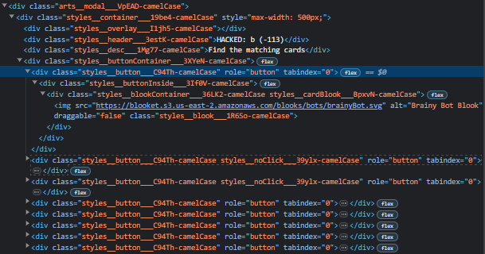

Set the temperature:  
<div class="arts__modal___VpEAD-camelCase"><div class="styles__container___19be4-camelCase" style="max-width: 380px;"><div class="styles__overlay___I1jh5-camelCase"></div><div class="styles__header___3estK-camelCase">HACKED: a (-235)</div><div class="styles__desc___1Mg77-camelCase">Set the temperature to 94°</div><div class="styles__buttonContainer___3XYeN-camelCase"><div class="styles__button___C94Th-camelCase" role="button" tabindex="0"><div class="styles__buttonInside___3If0V-camelCase">&lt;</div></div><div class="styles__temperature___3GYce-camelCase">72°</div><div class="styles__button___C94Th-camelCase" role="button" tabindex="0"><div class="styles__buttonInside___3If0V-camelCase">&gt;</div></div></div></div></div>

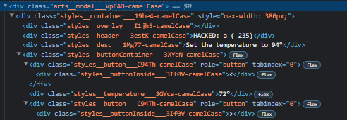

You can click as fast as you want

Complete the upload

<div class="arts__modal___VpEAD-camelCase"><div class="styles__container___19be4-camelCase"><div class="styles__overlay___I1jh5-camelCase"></div><div class="styles__header___3estK-camelCase">HACKED: b (-121)</div><div class="styles__desc___1Mg77-camelCase">Complete the upload</div><div class="styles__progressHolder___2QMz5-camelCase"><div class="styles__progress___2EK4p-camelCase" style="transform: translateX(-100%);"></div></div><div class="styles__buttonContainer___3XYeN-camelCase"><div class="styles__longButton___3h2eR-camelCase" role="button" tabindex="0">Start Upload</div></div></div></div>

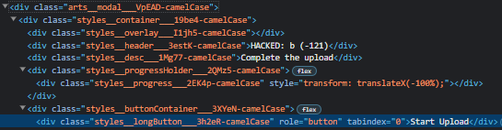

After clicking: <div class="styles__desc___1Mg77-camelCase" style="margin: 10px;">Loading...</div>

Click the numbers from 1 to 10:

<div class="arts__modal___VpEAD-camelCase"><div class="styles__container___19be4-camelCase"><div class="styles__overlay___I1jh5-camelCase"></div><div class="styles__header___3estK-camelCase">HACKED: a (-2.5K)</div><div class="styles__desc___1Mg77-camelCase">Click the numbers from 1 to 10</div><div class="styles__buttonContainer___3XYeN-camelCase"><div class="styles__button___C94Th-camelCase" role="button" tabindex="0"><div class="styles__buttonInside___3If0V-camelCase">7</div></div><div class="styles__button___C94Th-camelCase" role="button" tabindex="0"><div class="styles__buttonInside___3If0V-camelCase">2</div></div><div class="styles__button___C94Th-camelCase" role="button" tabindex="0"><div class="styles__buttonInside___3If0V-camelCase">8</div></div><div class="styles__button___C94Th-camelCase" role="button" tabindex="0"><div class="styles__buttonInside___3If0V-camelCase">3</div></div><div class="styles__button___C94Th-camelCase" role="button" tabindex="0"><div class="styles__buttonInside___3If0V-camelCase">1</div></div><div class="styles__button___C94Th-camelCase" role="button" tabindex="0"><div class="styles__buttonInside___3If0V-camelCase">10</div></div><div class="styles__button___C94Th-camelCase" role="button" tabindex="0"><div class="styles__buttonInside___3If0V-camelCase">4</div></div><div class="styles__button___C94Th-camelCase" role="button" tabindex="0"><div class="styles__buttonInside___3If0V-camelCase">5</div></div><div class="styles__button___C94Th-camelCase" role="button" tabindex="0"><div class="styles__buttonInside___3If0V-camelCase">6</div></div><div class="styles__button___C94Th-camelCase" role="button" tabindex="0"><div class="styles__buttonInside___3If0V-camelCase">9</div></div></div></div></div>

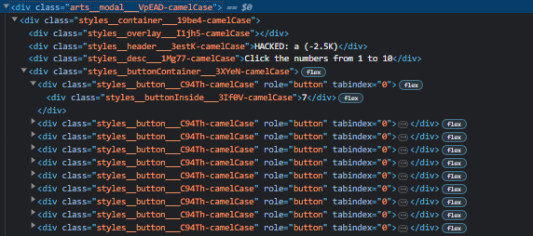

<div class="styles__button___C94Th-camelCase styles__chosen___3pT3X-camelCase" role="button" tabindex="0"><div class="styles__buttonInside___3If0V-camelCase">1</div></div>

SWAP COLORS

<div class="arts__modal___VpEAD-camelCase"><div class="styles__container___19be4-camelCase" style="max-width: 510px;"><div class="styles__overlay___I1jh5-camelCase"></div><div class="styles__header___3estK-camelCase">HACKED: a (-37)</div><div class="styles__desc___1Mg77-camelCase">Reorder the right colors to match left (click to swap right colors)</div><div class="styles__buttonContainer___3XYeN-camelCase"><div class="styles__wireRow___3vwnr-camelCase"><div class="styles__button___C94Th-camelCase styles__noClick___39ylx-camelCase" style="background-color: rgb(255, 51, 51);"><div class="styles__buttonInside___3If0V-camelCase"><i class="styles__icon___3nqr5-camelCase fas fa-heart" aria-hidden="true"></i></div></div><div class="styles__wire___4ieGM-camelCase" style="opacity: 0; background-color: rgb(71, 209, 71); outline-color: rgb(71, 209, 71);"></div><div class="styles__button___C94Th-camelCase" role="button" tabindex="0" style="background-color: rgb(71, 209, 71);"><div class="styles__buttonInside___3If0V-camelCase"><i class="styles__icon___3nqr5-camelCase fas fa-square" aria-hidden="true"></i></div></div></div><div class="styles__wireRow___3vwnr-camelCase"><div class="styles__button___C94Th-camelCase styles__noClick___39ylx-camelCase" style="background-color: rgb(51, 133, 255);"><div class="styles__buttonInside___3If0V-camelCase"><i class="styles__icon___3nqr5-camelCase fas fa-circle" aria-hidden="true"></i></div></div><div class="styles__wire___4ieGM-camelCase" style="opacity: 0; background-color: rgb(255, 255, 102); outline-color: rgb(255, 255, 102);"></div><div class="styles__button___C94Th-camelCase" role="button" tabindex="0" style="background-color: rgb(255, 255, 102);"><div class="styles__buttonInside___3If0V-camelCase"><i class="styles__icon___3nqr5-camelCase fas fa-star" aria-hidden="true"></i></div></div></div><div class="styles__wireRow___3vwnr-camelCase"><div class="styles__button___C94Th-camelCase styles__noClick___39ylx-camelCase" style="background-color: rgb(71, 209, 71);"><div class="styles__buttonInside___3If0V-camelCase"><i class="styles__icon___3nqr5-camelCase fas fa-square" aria-hidden="true"></i></div></div><div class="styles__wire___4ieGM-camelCase" style="opacity: 0; background-color: rgb(255, 51, 51); outline-color: rgb(255, 51, 51);"></div><div class="styles__button___C94Th-camelCase" role="button" tabindex="0" style="background-color: rgb(255, 51, 51);"><div class="styles__buttonInside___3If0V-camelCase"><i class="styles__icon___3nqr5-camelCase fas fa-heart" aria-hidden="true"></i></div></div></div><div class="styles__wireRow___3vwnr-camelCase"><div class="styles__button___C94Th-camelCase styles__noClick___39ylx-camelCase" style="background-color: rgb(255, 255, 102);"><div class="styles__buttonInside___3If0V-camelCase"><i class="styles__icon___3nqr5-camelCase fas fa-star" aria-hidden="true"></i></div></div><div class="styles__wire___4ieGM-camelCase" style="opacity: 0; background-color: rgb(51, 133, 255); outline-color: rgb(51, 133, 255);"></div><div class="styles__button___C94Th-camelCase" role="button" tabindex="0" style="background-color: rgb(51, 133, 255);"><div class="styles__buttonInside___3If0V-camelCase"><i class="styles__icon___3nqr5-camelCase fas fa-circle" aria-hidden="true"></i></div></div></div></div></div></div>

